PREMIT

NURUL

DIYANA

IQBAL

NURAIN

SHAMALA

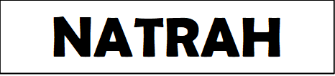

AMIR

ASYIKIN

FAUZI

HANANI

SYARIEF